**GDC 2017 Report**

**Gilles Monteil – Animation Content Manager**

**Editorial**

**Based in Montpellier**

**UNCHARTED 4 ANIMATION PIPELINE**

**Jeremy Yates**

Emphases on Video Visualization benchmark where they confirm the relevancy of Ipad session ++ done by WD2

They really pushed it to having sets, actors (even if their lead animator played Nathan), even makeup.

Second learning; data tracking and validation tool (some sort of Animation central) to provide tasks and evolution for each scenes.

**Almudena Soria**

Prototyping with scripts.

Everything system shown were done using data to cover all possible situations

First pass with proto data then refinement and data addition

Systems done:

* seamless transitions to interactive object done with data
* NPC attacks on cars (+ some physic addition)
* Monkey interaction with Main character
* Navigation on crowd system

**THE WITCHER 3 : PUSHING BOUNDARIES : animating expansion packs for the “Witcher 3 wild hunt”**

**Sebastian Kalemba**

They just use Motion Builder.

Stable tech, no support

Motion capture was done by the animators (acting, directing and processing). First with an Optitrack but then they bought a Vicon system and created a motion capture department

They had a dedicated team for Monsters but some of them were a nightmare to animate because of design issue that were sometime over the top … it seems that communication between Animation department and design was an issue.

**PROCEDURAL NARRATIVE GENERATION**

**North Carolina state university:**

tools for rapide prototyping story (chris Martens@chrismaphone)

Two approaches :

* Simulation driven (Dwarf Fortress: simulation on storygen.org)
  + The Ant and the Dove example
  + Logical modeling of the characters and their changing situations
  + Interacting rule is a transition between two situations
* Plot driven approach :
  + Narrative agenda
  + Trajectory of desired narratives (exeptions)
  + Re-plan (Façade, base case)

Going from plot-ca to discourse-ca: NaNoGenMo (National Novel Generation Month)

**HORIZON ZERO DAWN: NARRATIVES**

**Non Linear Narrative**

Talking about relax or strict Quest system and where they placed themselves (red mark)

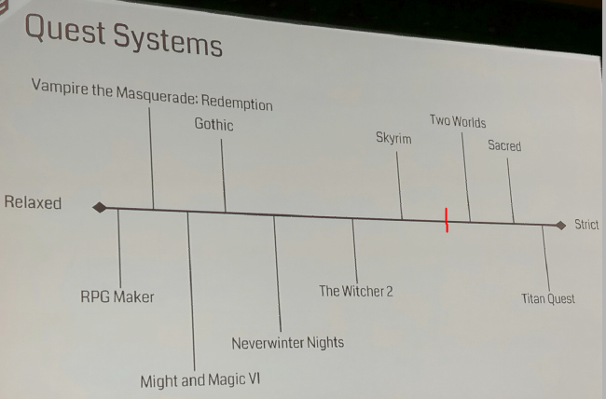

They did a tool that permit mission design to create 150 quests

They use verbs to manage the chain of events. Verbs are the links from one event to another one

Graph Theory: wall of sticky notes

It’s a cause effect system and they manages a chain of events

Basically they put all situations inside a “paper note” and then they figure out what are the verbs that connect each of them

**Problems:**

They list of verb they had, was not sufficient

They also had this following time travel issue

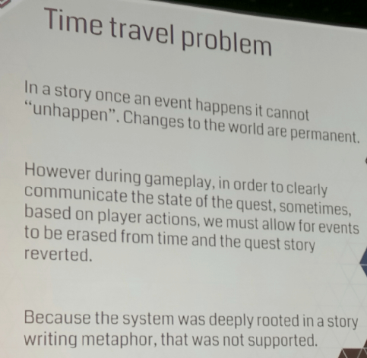

**AI AND FULLBODY ANIMATION ON DOOM**

[jakecampbell@gmail.com](mailto:jakecampbell@gmail.com)

Everything was integrated in fullbody in order to give more control to animators except small Hits that are layered and death, which blended to ragdoll

They were also warping data in the following way

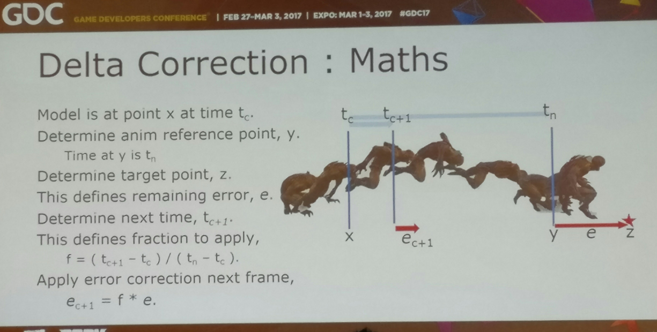

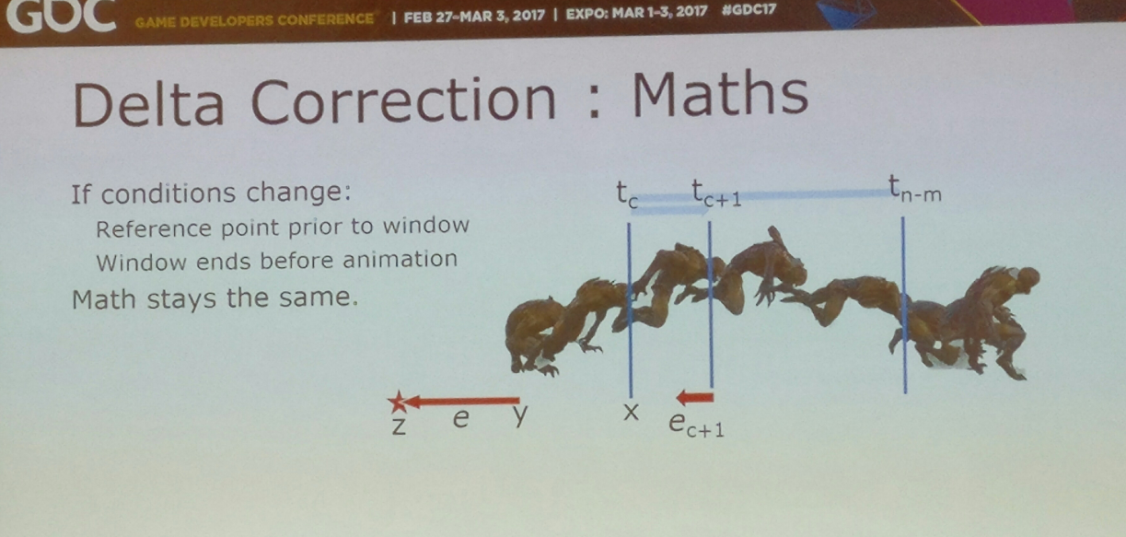

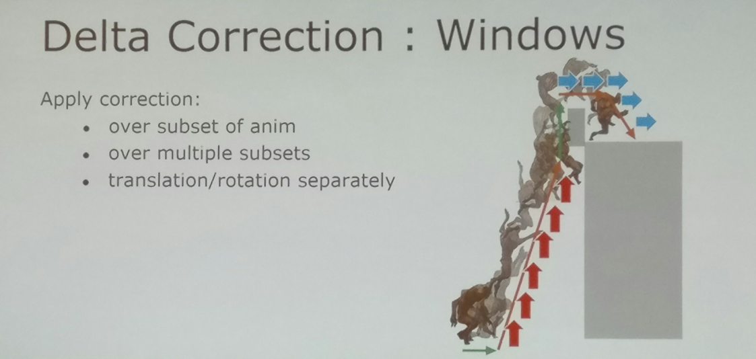

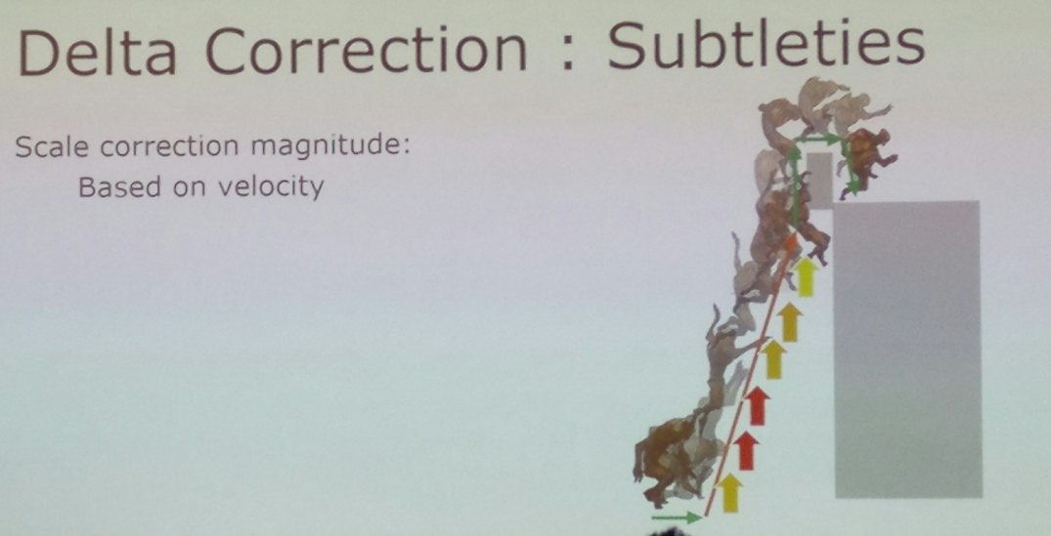

The way they synchronize animation with phases

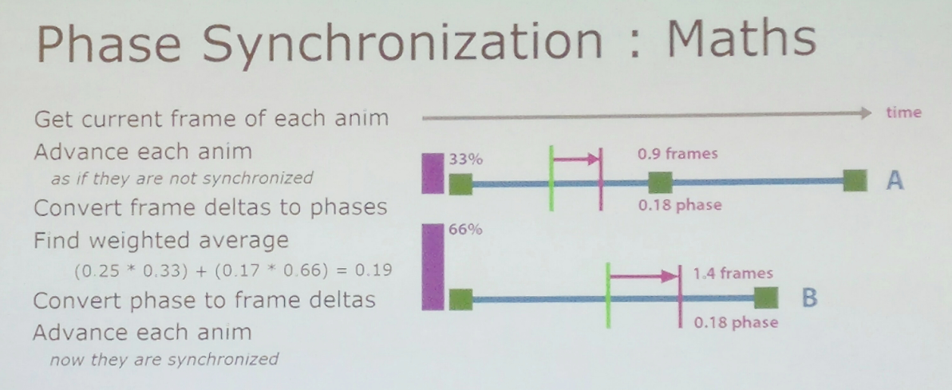

The way they track the lookat in order to keep data rolling under

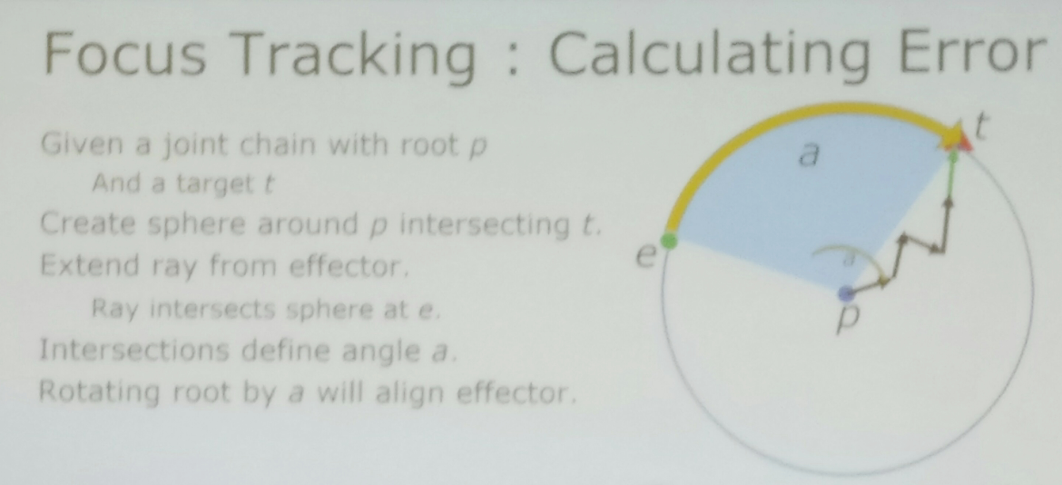

Blending locomotion:

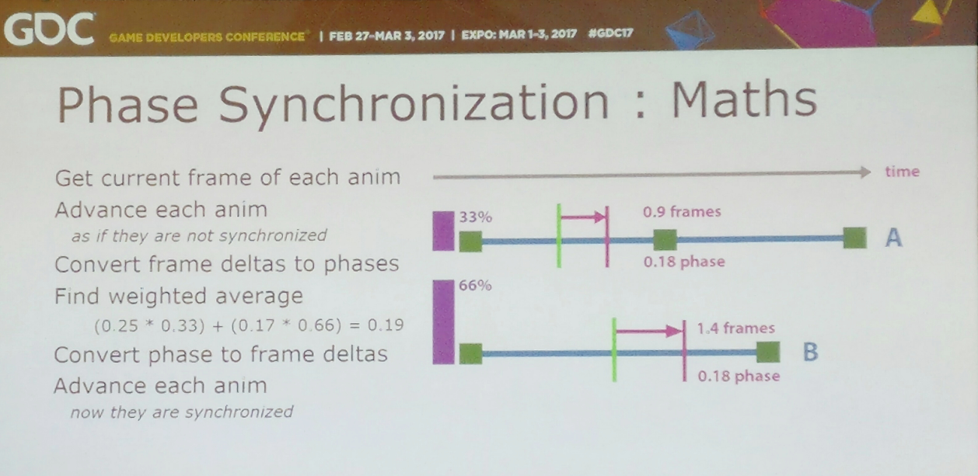

**MOTION WARPING IN GEARS OF WAR 4**

**Steven Dinkinson** (ex TDa of ACU)

This talk was about how to make an entry jumps coverage with only one animation

This was possible by:

* Creating warp points on geometry of jumpable objects
* adjust the facing of the animation during the entry
* then adjust distance and orientation separately until it match the jump start

Result: a BIG slide to get at cover

Then he adjusts the distance of the top of the jump to fit the geometry of the jumpable object with another warp point and another BIG slide

**ALTERNATE ANIMATION ROUND TABLE**

Because of the success of the official animation roundtable, we decided to create an alternate one, in the corridor with the people who didn’t get the chance to go inside the official one.

Discussion was about the importance of creating style even with motion capture. When to use it as is and when to push it in term of posing and timing.

Alex Drouin, Kristjan Zadzuik and I were there to talk about the way the first Assassin was made

Other discussion was about the bad consideration on videogame animation in comparison of the Film one… but everybody agreed on the fact that creating game animation was more satisfying because animators were in better control and real actors on the final product which is not at all the same feeling for films

**UNREAL4 TECHNICAL SHOWCASE**

**Rigging runtime**

**Pose driver**

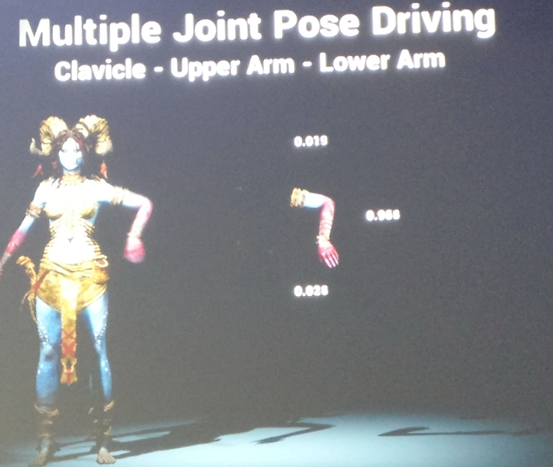

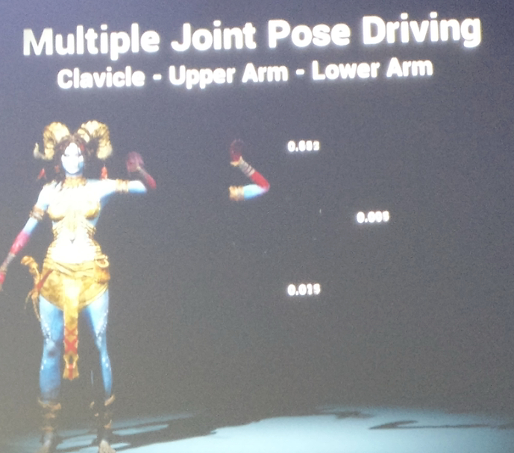

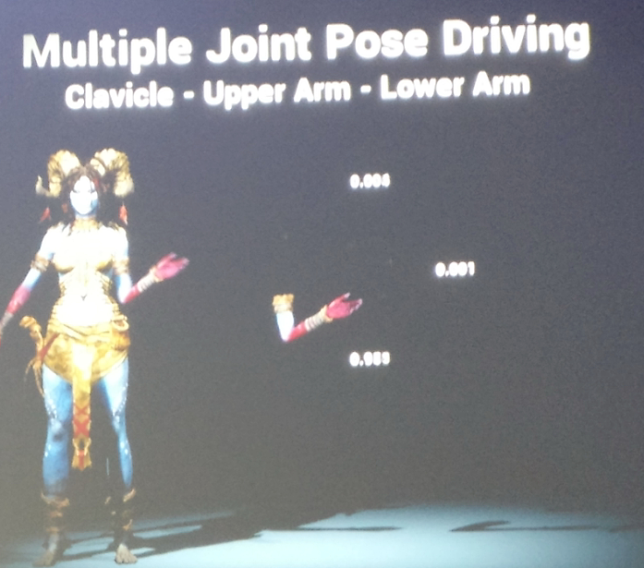

**Radial basis function**

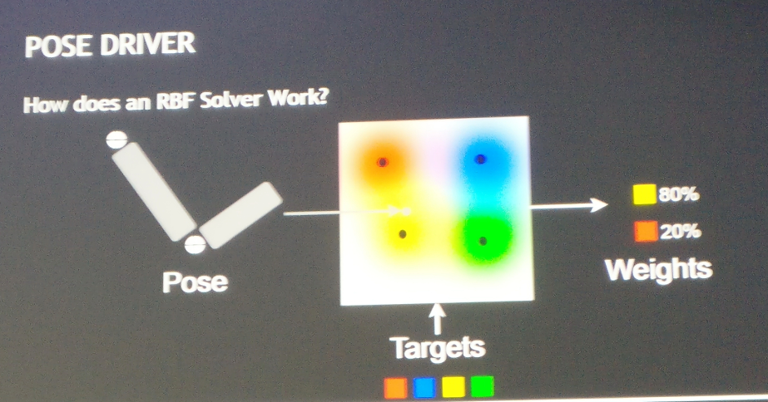

**Live link** (equivalent to passenger)

**Clothing pipeline** --- epic clothing tool in Maya brought in Unreal4

**Immediate mode Physic**

**Character editor**

For now 60 characters - 50 shapes

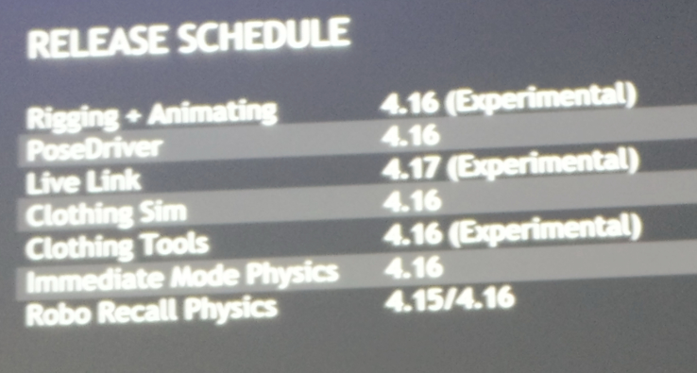

**N-TERAC**

**EA**

Tool developed for Madden, NBA and plus…

They had a system with only 2 characters before

The way it work :

* you have some roles (called slot) of characters (called tracks) and some non-unique roles (defenders, enemies)
* a ball carrier can be surrounded by 8 tacklers

then..

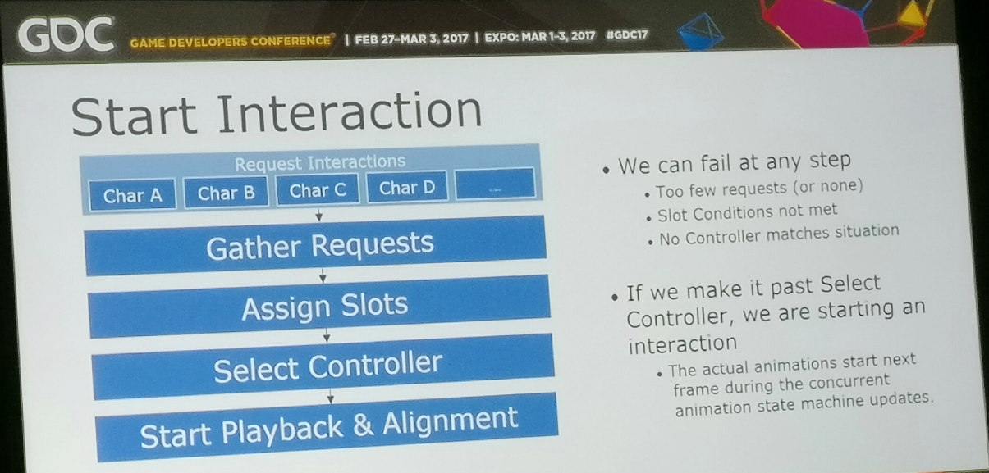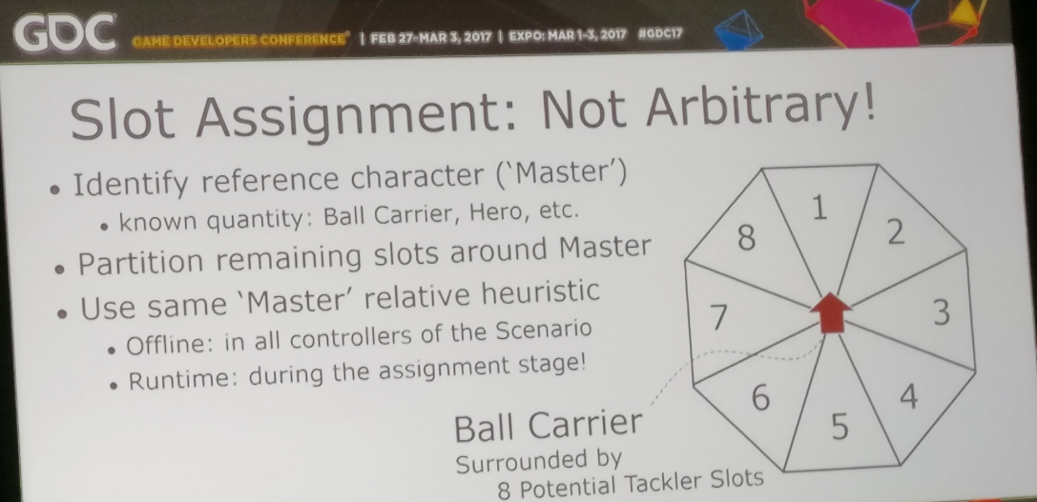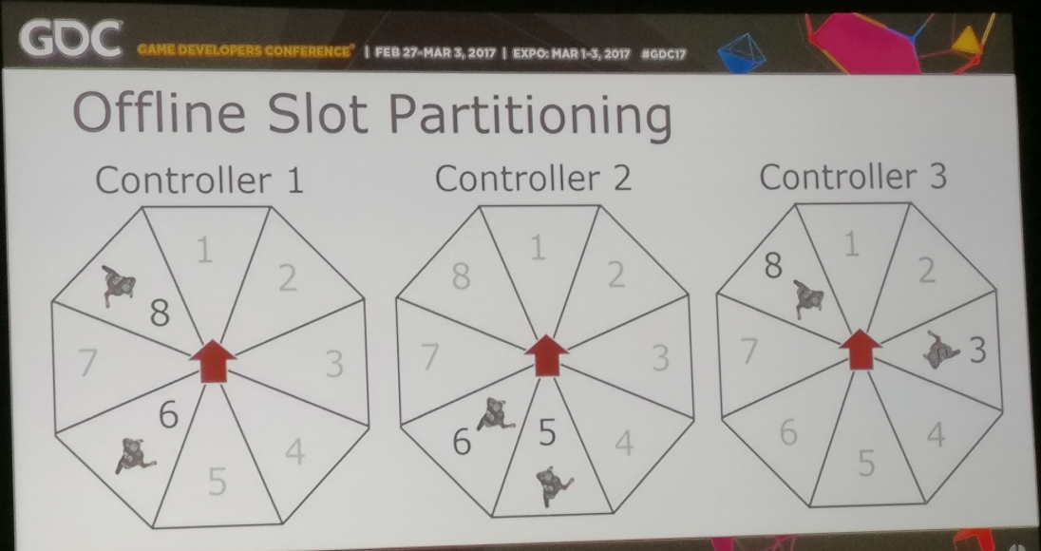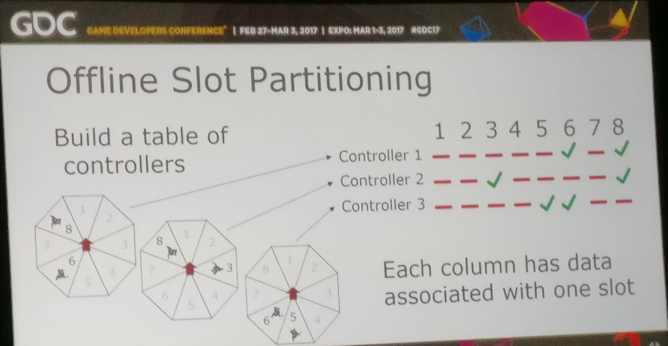

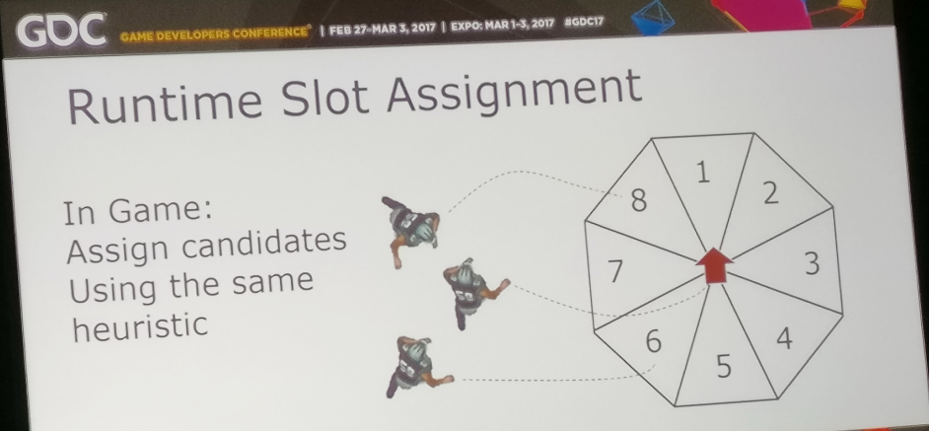

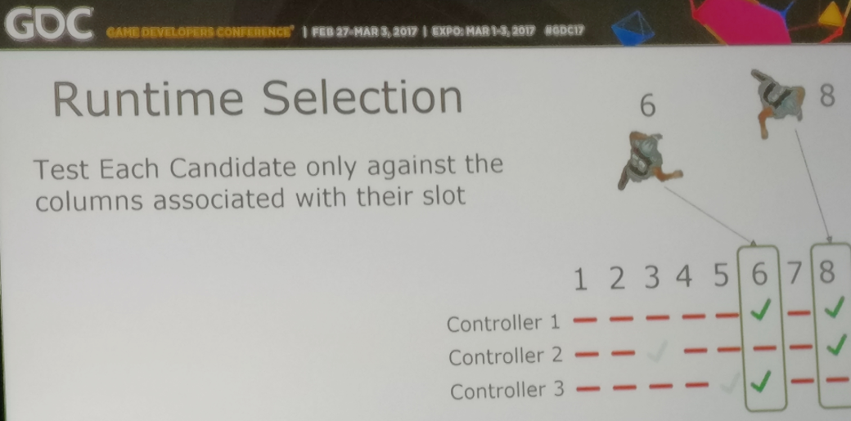

**PLAYER TRAVERSAL MECHANICS IN THE VAST WORLD OF HORIZON ZERO DAWN**

**Paul van Grinsven**

**Thijs Kruistof**

**All the slides and videos are here:**

<https://www.guerrilla-games.com/read/player-traversal-mechanics-in-the-vast-world-of-horizon-zero-dawn>

2 programmers and 3 animators on the main character

They used Maya and Mobu

Morpheme connect on their DECIMA engine and editor with Morheme Runtime

On their start and stop they allow early exits

3 starts: forward, right and left

Move speed and heading

They keep the history of the 3 last input frames

No nav mesh for the player but capsule shaper collider… they need to know ground surface gradient (ignoring high frequencies)

Additif animations based on slope angle

Raycast for knee hight. They use a 2 bone IK for the legs and foot rest events put in the animation

They have a foot system to avoid floating foot with some additional collision probing. They don’t just apply vertical adjustments but also horizontal (picture ?)

They do some intersection tests

Transitions are evaluate by some arguments then they apply warping adjustment.

* Displacement by axis in source animation
* Tag warping availability (got an idea.. to force local poses on warping distance)
* They preserve the duration by adjusting the speed of the animation

They annotate the geometry in a static or dynamic way to provide semantic

Jump:

* Auto guided with a sensation of keeping control
* Motion planning with motion tables that store the animation metrics
* X and y in the table are variables and can predict the desired trajectory

Just one attach point between legs and between hands to adjust IK for climbing on dynamic objects

**TOOLS FOR GD:**

**Machinations**

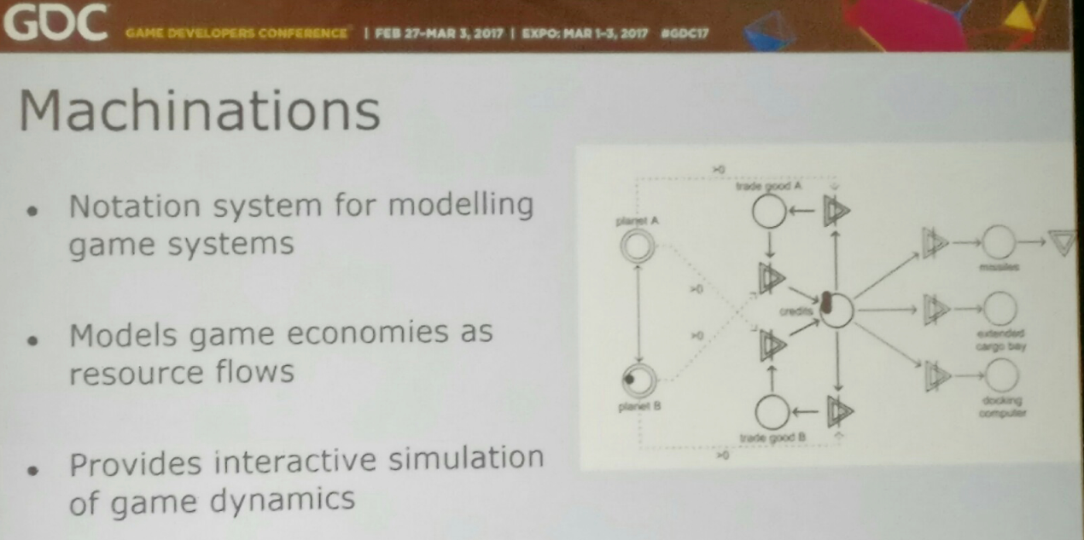

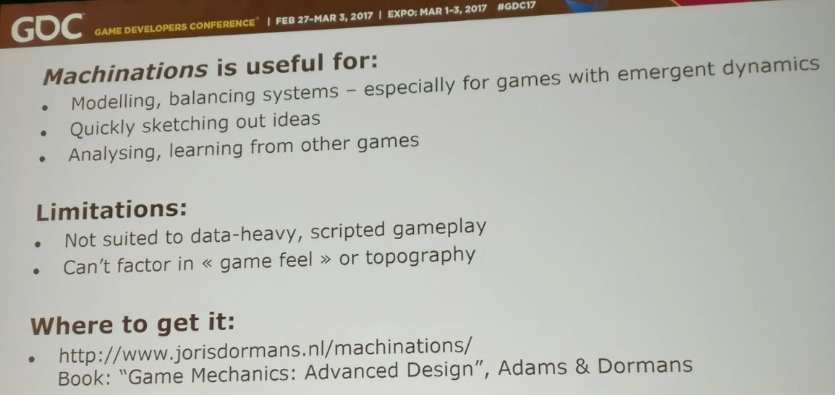

**Articy : Draft**

narrative and mission design

dialog heavy games

organising and visualing design and narratives materials

<http://www.nevigo.com/en/articydraft/overview/>

**skill atoms**

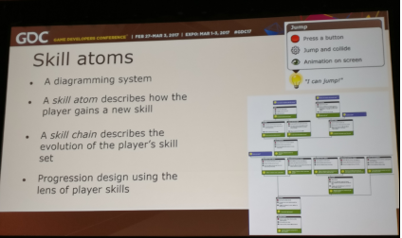

**Sentient Sketchbook** ( sentientsketchbook.com )

Designed for strategy games

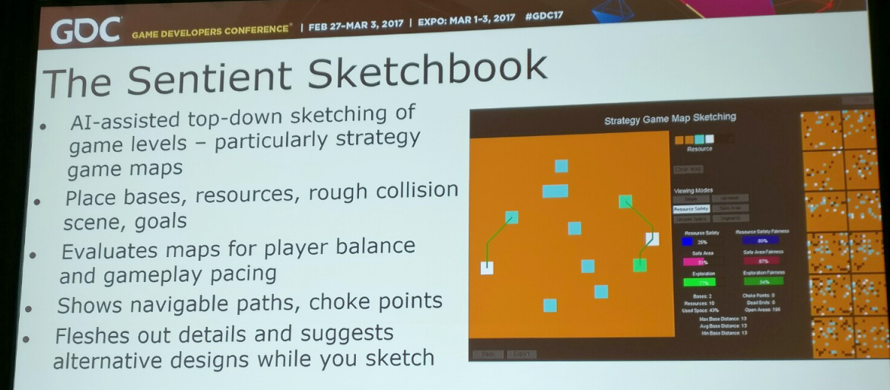

**Ludoscope**

mission and level design

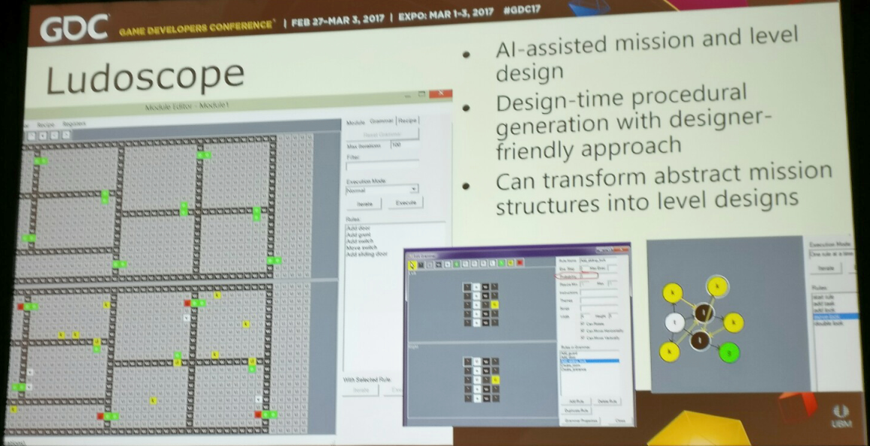

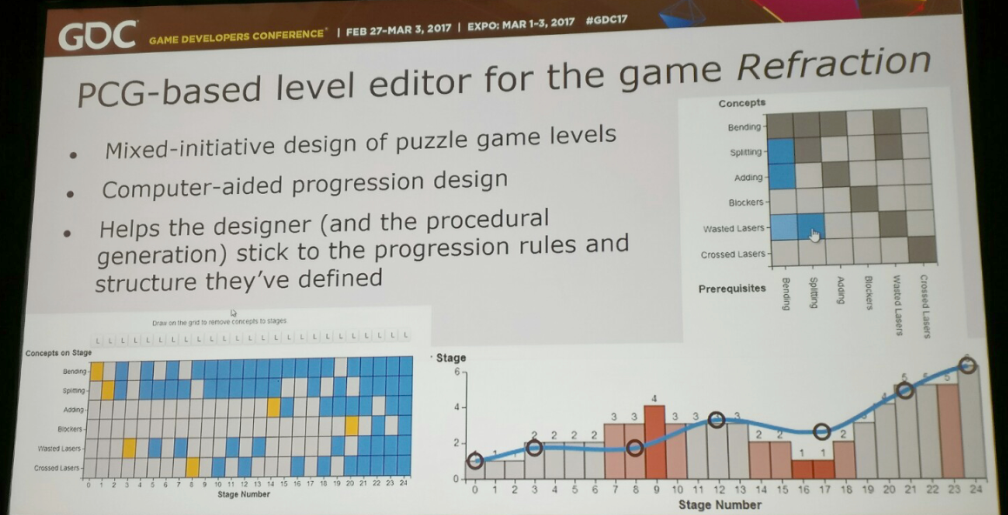

**Progressimo**

inspire by progression structure idea… game states

doesn’t do the presentation

not done for emergent systems (use Machinations for this)

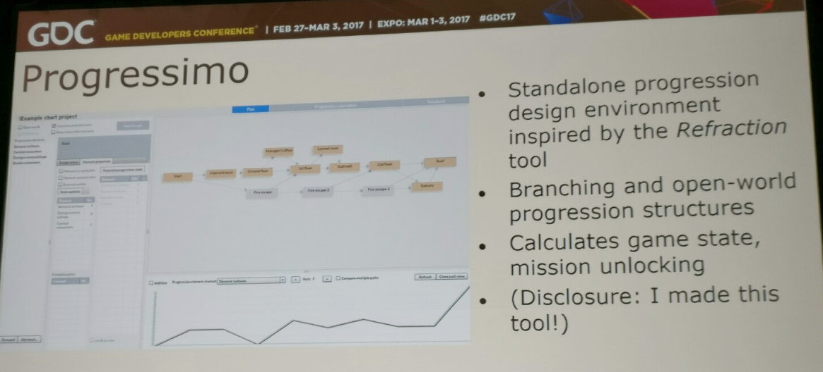

**Conclusion:**

Use a mixe of the different tools… toolbox approach (not just one tool to do everything)

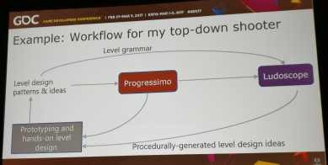

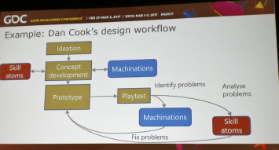

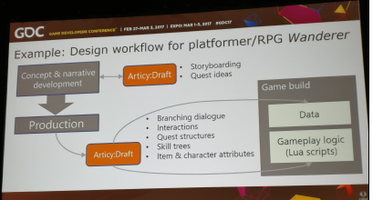

**DATA DRIVEN COMMUNITY**

[richard@feverbee.com](mailto:richard@feverbee.com)

richmillington

Advices on community management:

* Get data and see what is popular and do more of them
* Post news everyday
* There are more interest on people than the subject of the community
* Reward the one who participate the most
* Look for questions not answers
  + Ask for anonymous answers for the others but not for you
* Newcomers should know how they can participate
* Social identity theory : the more the group is successful, the more they want to participate
* Speed vs effort
* How to populate people interests
* Make direct requests for information
* Specific requests increase participation
* Make sure newcomers get quick reply (if not they won’t participate)
* top 20 discussions are responsible for 50% page views
* building a sense of community: personality of the year
* send a survey increase the sense of membership
* introduce ritual and tradition: have a unique shared experiences
* use common symbol systems - use the same language as you audience
* give the opportunity to your members to show what they do
* create a sense of success: clear common goal
* lifo vs fifo (first answered… by the bottom)
* better perception of an answer coming from a member rather from a FAQ
* Question starting with HOW have more answers
* Create a custom dashboard

**NARRATIVE IN SORCERY**

Don’t like at all the AC system

Sorcery is more based on Witcher3 but with some addition on quests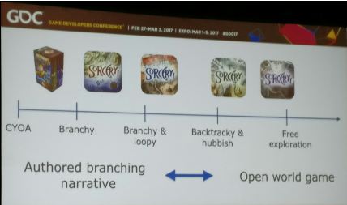

Open world shoud be open and not authored

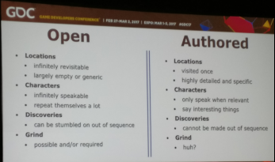

the aim: an authored branching narrative that copes despite an open world

no quests but encounters

Image showing the poverty of quest structure

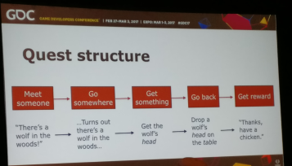

Design problematic

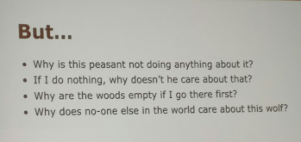

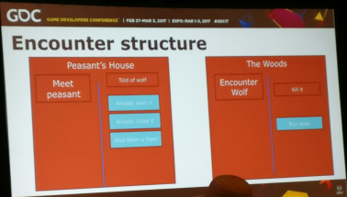

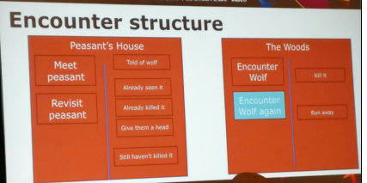

Encounter philosophy solve the problematic of coherency

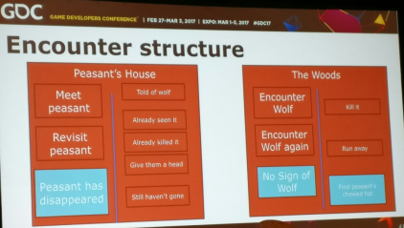

Trees are not player target

If you take a state, all of what is before has already happened

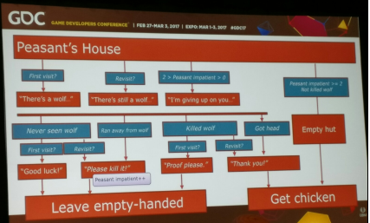

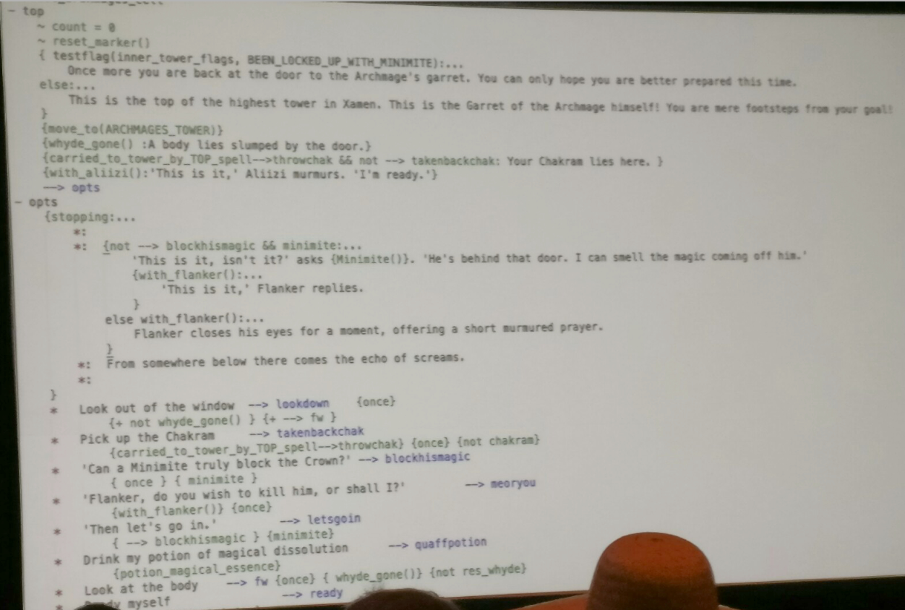

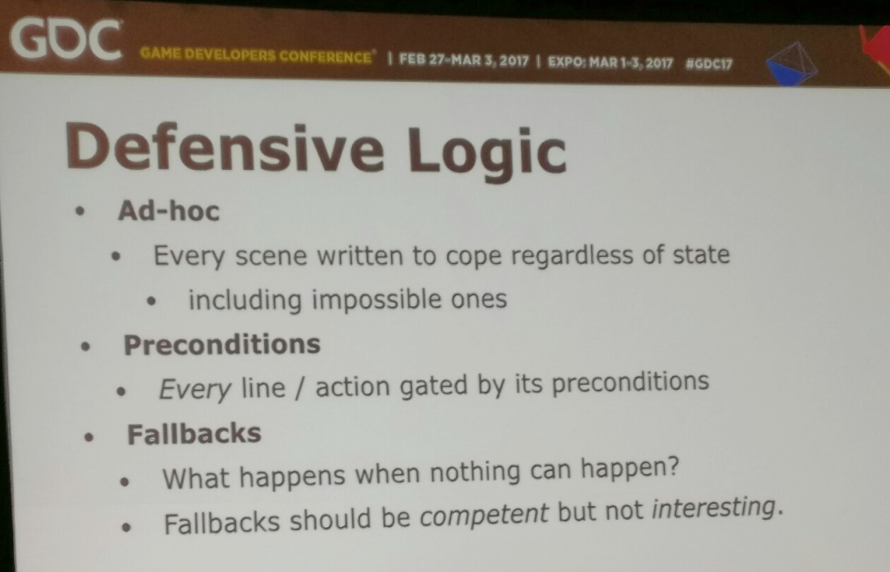

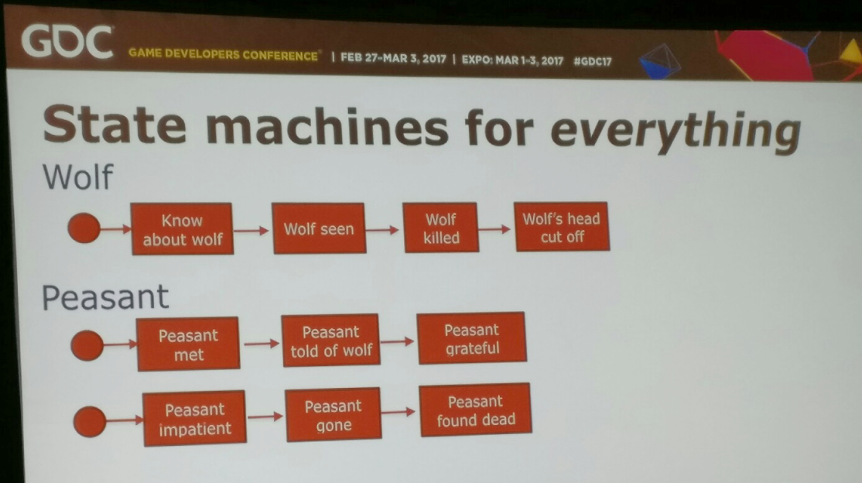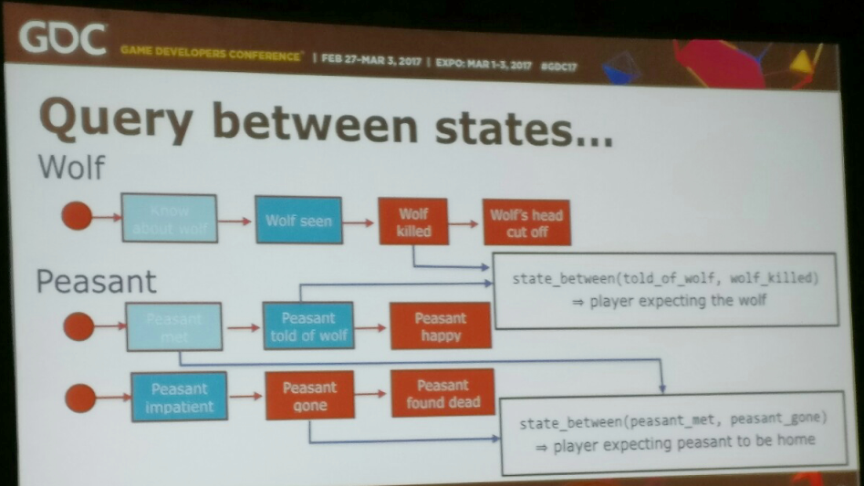

Emergeant story

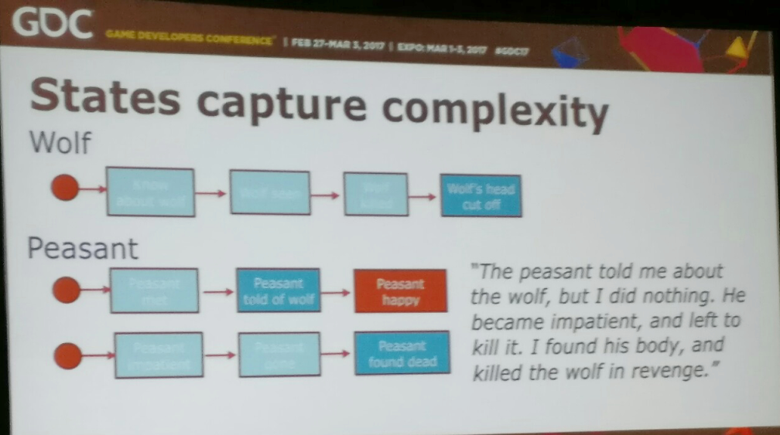

Advantages :

* plot can start in different ways

State tree can drive the plot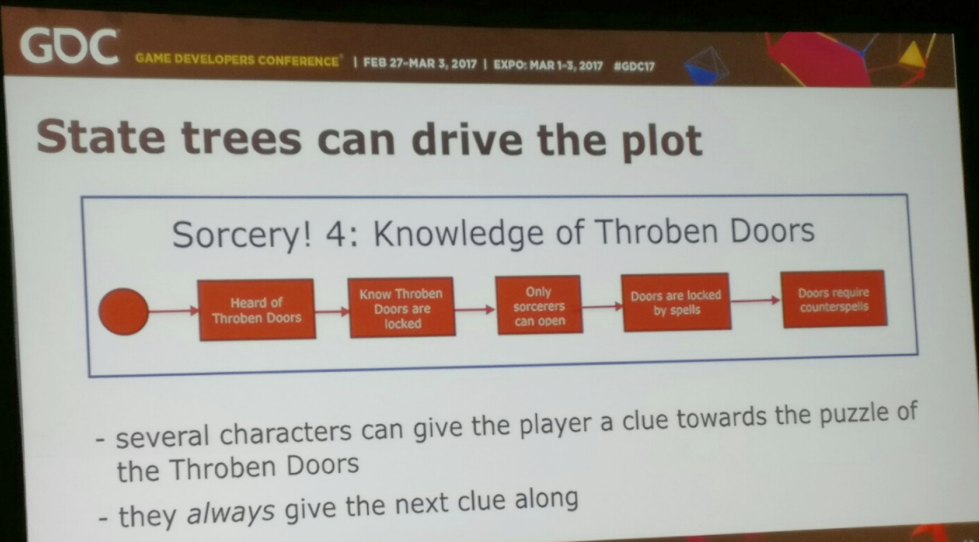

Image

simulationist gameplay dans sorcery 3

bag of content depending of the choice of the player by dropping encounters

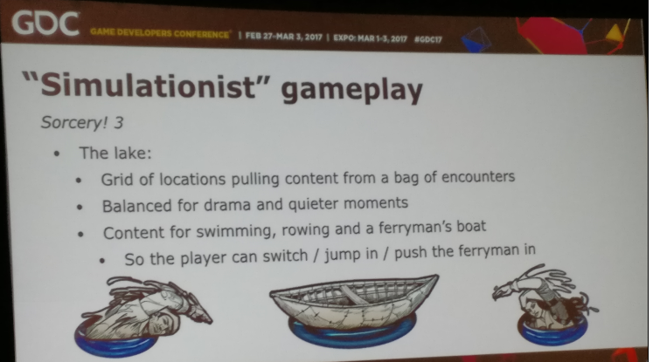

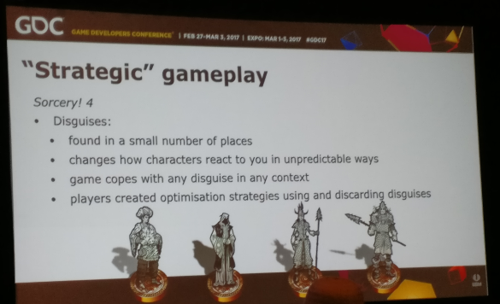

Emergent solutions costs:

* unpredictability
  + you don’t know what player need to know but you can still use bottlenecks
* redundancy
  + most content will go unseen by any player
  + But it will be seen by somebody and that will be special for him
* Bugs
  + Most of the time due to a missing precondition

Their next game Heaven’s Vault… more like Mass Effect

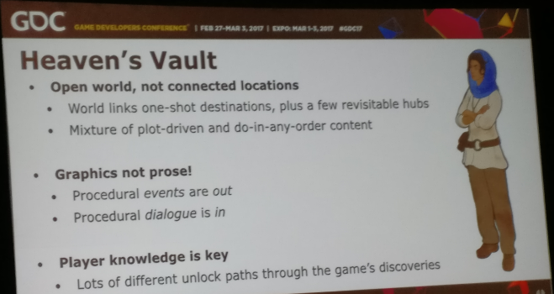

@joningold